Anthony Meunier

DeVry University

CIS 355A

Week 2 iLab

StudentGPAInfo

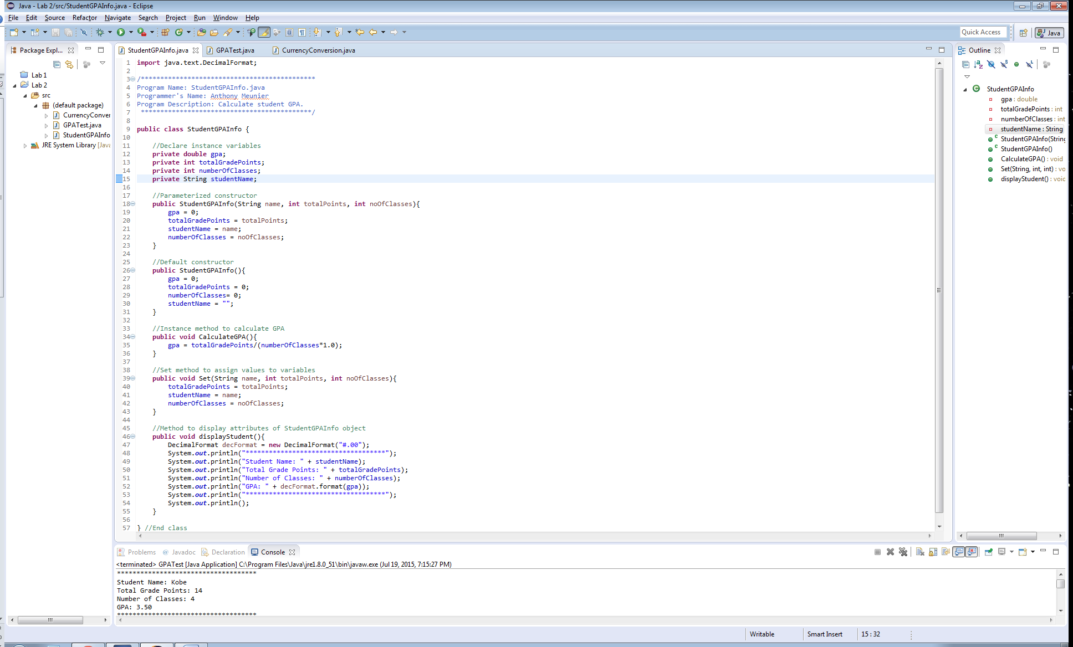

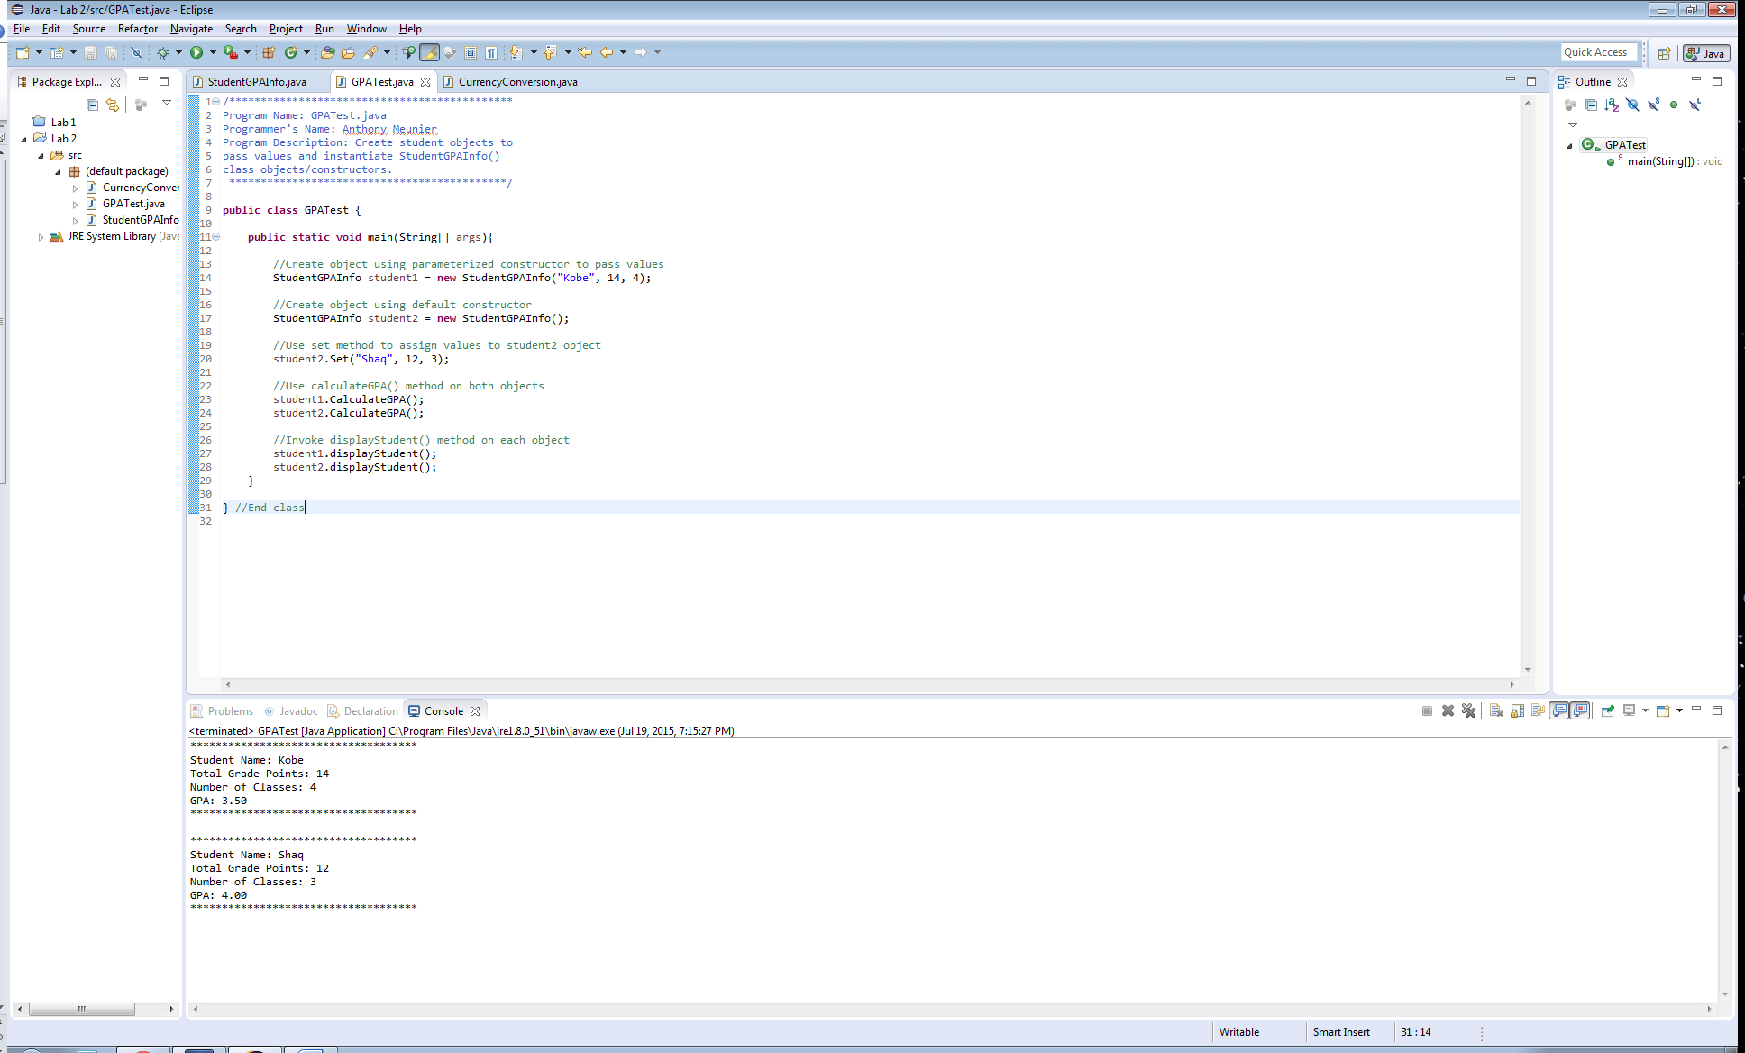

**import** java.text.DecimalFormat;

/*********************************************

Program Name: StudentGPAInfo.java

Programmer's Name: Anthony Meunier

Program Description: Calculate student GPA.

********************************************/

**public** **class** StudentGPAInfo {

//Declare instance variables

**private** **double** gpa;

**private** **int** totalGradePoints;

**private** **int** numberOfClasses;

**private** String studentName;

//Parameterized constructor

**public** StudentGPAInfo(String name, **int** totalPoints, **int** noOfClasses){

gpa = 0;

totalGradePoints = totalPoints;

studentName = name;

numberOfClasses = noOfClasses;

}

//Default constructor

**public** StudentGPAInfo(){

gpa = 0;

totalGradePoints = 0;

numberOfClasses= 0;

studentName = "";

}

//Instance method to calculate GPA

**public** **void** CalculateGPA(){

gpa = totalGradePoints/(numberOfClasses*1.0);

}

//Set method to assign values to variables

**public** **void** Set(String name, **int** totalPoints, **int** noOfClasses){

totalGradePoints = totalPoints;

studentName = name;

numberOfClasses = noOfClasses;

}

//Method to display attributes of StudentGPAInfo object

**public** **void** displayStudent(){

DecimalFormat decFormat = **new** DecimalFormat("#.00");

System.***out***.println("************************************");

System.***out***.println("Student Name: " + studentName);

System.***out***.println("Total Grade Points: " + totalGradePoints);

System.***out***.println("Number of Classes: " + numberOfClasses);

System.***out***.println("GPA: " + decFormat.format(gpa));

System.***out***.println("************************************");

System.***out***.println();

}

} //End class

/*********************************************

Program Name: GPATest.java

Programmer's Name: Anthony Meunier

Program Description: Create student objects to

pass values and instantiate StudentGPAInfo()

class objects/constructors.

********************************************/

**public** **class** GPATest {

**public** **static** **void** main(String[] args){

//Create object using parameterized constructor to pass values

StudentGPAInfo student1 = **new** StudentGPAInfo("Kobe", 14, 4);

//Create object using default constructor

StudentGPAInfo student2 = **new** StudentGPAInfo();

//Use set method to assign values to student2 object

student2.Set("Shaq", 12, 3);

//Use calculateGPA() method on both objects

student1.CalculateGPA();

student2.CalculateGPA();

//Invoke displayStudent() method on each object

student1.displayStudent();

student2.displayStudent();

}

} //End class

CurrencyConversion

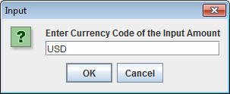

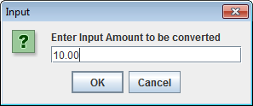

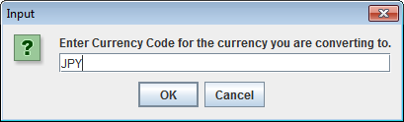

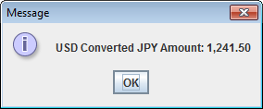

**import** java.text.DecimalFormat;

**import** javax.swing.JOptionPane;

/*********************************************

Program Name: CurrencyConversion.java

Programmer's Name: Anthony Meunier

Program Description: Converts money between currencies using JOptionPane GUI.

********************************************/

**public** **class** CurrencyConversion {

//Method to gather input and display output

**public** **static** **void** main(String[] args) {

//Objects to gather input

String SourceCurrency = JOptionPane.*showInputDialog*("Enter Currency Code of the Input Amount");

**double** Amount = Double.*parseDouble*(JOptionPane.*showInputDialog*("Enter Input Amount to be converted"));

String TargetCurrency = JOptionPane.*showInputDialog*("Enter Currency Code for the currency you are converting to.");

**double** ConvertedAmount = *ConvertCurrency*(Amount,SourceCurrency,TargetCurrency);

DecimalFormat df = **new** DecimalFormat("#,###.00");

//Display output

**if**(ConvertedAmount == -1){

JOptionPane.*showMessageDialog*(**null**, "Unable to calculate conversion. Please enter the valid inputs");

}

**else**{

JOptionPane.*showMessageDialog*(**null**, SourceCurrency + " Converted " + TargetCurrency + " Amount: "+ df.format(ConvertedAmount));

}

}

//Method to perform currency conversions

**public** **static** **double** ConvertCurrency(**double** Amount, String SourceCurrency, String TargetCurrency) {

//Convert from USD

**double** convertedAmount = -1;

SourceCurrency = SourceCurrency.trim().toUpperCase();

TargetCurrency = TargetCurrency.trim().toUpperCase();

**switch**(SourceCurrency){

**case** "USD":

**if**(TargetCurrency.equals("POUND")){

convertedAmount = Amount * 0.64;

}

**else** **if**(TargetCurrency.equals("JPY")){

convertedAmount = Amount * 124.15;

}

**break**;

//Convert from POUND

**case** "POUND":

**if**(TargetCurrency.equals("USD")){

convertedAmount = Amount / 0.64;

}

**else** **if**(TargetCurrency.equals("JPY")){

convertedAmount = Amount * 193.58;

}

**break**;

//Convert from JPY

**case** "JPY":

**if**(TargetCurrency.equals("USD")){

convertedAmount = Amount / 124.15;

}

**else** **if**(TargetCurrency.equals("POUND")){

convertedAmount = Amount / 193.58;

}

**break**;

}

**return** convertedAmount;

}

} //End class